Use this reference to complete the Friends and Family Action Item as part of the student onboarding process.

The Friends and Family Action Item requires that you declare an emergency contact and parent.

INSTRUCTIONS

- Log into Workday. In “My Tasks”, select the “Review My Friends and Family” action item.

To complete the onboarding process, you must add an emergency contact and a parent. To begin, locate and click the “Add” button.



- On the Edit My Friends and Family page, find and click the “Relationship Types” field to reveal a drop-down menu. For the purpose of onboarding, you must add an emergency contact and a parent.

Select “Emergency Contact”, “Parent” or both.
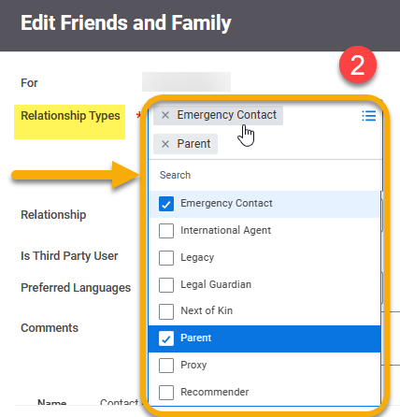
In this example, the new contact is both the parent and the emergency contact. If you want an emergency contact that is NOT a parent, you must add two contacts, one parent and one emergency contact.

- Find and click the “Relationship” field. If you chose the Parent: Relationship Type, then you must specify “Father” or “Mother”.

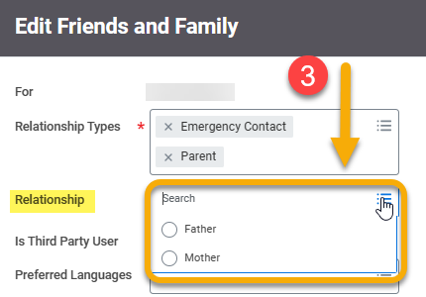

- Scroll down to the Name section. If there is not a blue line under Name, click to select. Complete required fields.

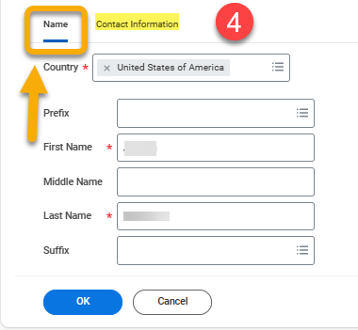

- Click “Contact Information” and complete required fields.



- Click “OK”.

- Click “Submit”.

